GIRI’S TECH HUB PVT.LTD – PUNE

Java Programming Test
Total Program: 9
Solve: any 6
Passing: 3 programs successfully run with code and logic explanation mandatory
Marking Scheme: 1 marks for every program and half mark for explanation so 9 marks for 6 programs and 1 mark for comment to code.

Section1: Looping and Pattern Section (total program 3 and solve any 2)
_________________________________________________________
Q1. Draw the following pattern?
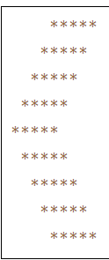
Q2. WAP to print the following pattern?
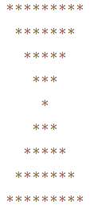
Q3. WAP to print the following series?
Given an integer, we have to write a Fibonacci series program in C up to the nth term using loop and recursion. We have to print all the numbers of the series from starting up to the Nth term where N is the input given by the user.
Example:
Input1: 10
Output1: 0 1 1 2 3 5 8 13 21 34
Explanation:
1st term = 0
2nd term = 1
3rd term = 1st term + 2nd term = 0 + 1 = 1
4th term = 2ndterm + 3rd term = 1 + 1 = 2
And so on……

Section2: Array and Character Array Section (total 3 program solve any 2)
______________________________________________________________________
Q1. Write a program in JAVA to find the second smallest element in an array without using sorting?
Q2. Write a program in JAVA to find create character array with size 10 and extract digit from character array and find its sum
Example: abc124mno5
Output: 1+2+4+5= 12
Q3. Write a program in C to rotate an array by N positions.
Expected Output:
The given array is : 0 3 6 9 12 14 18 20 22 25 27
From 4th position the values of the array are : 12 14 18 20 22 25 27
Before 4th position the values of the array are : 0 3 6 9
After rotating from 4th position the array is:
12 14 18 20 22 25 27 0 3 6 9

Section3: Classes & Object, constructor and inheritance (total 3 program solve any 2)
__________________________________________________________________________________
Q1. WAP to Create POJO class name as Employee with field id, name and salary and create array of object of size 5 and store data in employee objects and display it and input the id from keyboard and search employee data by using its id and if id found then display message employee is present otherwise show employee not present.
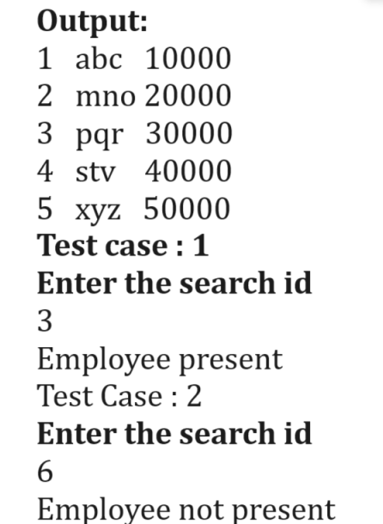

Q2. WAP to Create Billing Application using by using Dynamic Polymorphism Concept
So you have to create abstract class name as CalculateBill with two methods
Example:
class Product
{ private int id;
private String name;
private int rate;
private int qty;
//write here setter and getters
}
abstract class CalculateBill
{ void acceptProducts(Product …p)
{
}
abstract int getTotalBill();
}
We have to write two child classes name as BillWithGST and BillWithoutGST you have to inherit the CalculateBill class in BillWithGST and override int getTotalBill() and calculate the total bill with 18% gst and return id and you have to inherit the BillWithoutGST and override int getTotalBill() and calculate total bill without GST and return it.
You have to prepare following cases
Case 1: Calculate Bill with GST
Case 2: Calculate Bill without GST
Note: You have to use dynamic Polymorphism.

Q3. WAP to create class name as Player with three field id, name and run and create array of objects of size 5 and store 5 player data in it and arrange all players in ascending order.

